7.79: a) The mechanical energy increase of the car is
Let be the number of gallons of gasoline consumed.
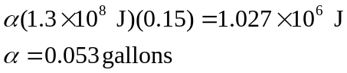

b)

